How to read a research paper (in this course)
- What is the main research question?
- What is the (empirical) motivation?
- What are the central mechanisms in the model?
- What is the simplest model in which we could capture these?
Consumption over the lifecycle: Gourinchas & Parker
- What is the main research question?
How households decide how much to consume and save over their lives.
- What is the (empirical) motivation?
The traditional hypothesis for consumption over the lifecycle is to consumption smooth. Consumption smoothing suggests that individuals should borrow when young, save during peak earning years and dissave during retirement. This is done to optimize standard of living over the lifecycle. In reality however, consumption seems to track income earned much closer, especially earlier in life which contradicts the hypothesis.
- What are the central mechanisms in the model?
They structurally estimate the full model using actual consumption and income data from about 40,000 households in the Consumer Expenditure Survey from 1980-1993. Using this they construct average consumption and income profiles across different ages, controlling for family size and group effects.
Two central mechanisms:
- Precautionary savings (dominates when young)
  - Income is risky You might get fired, get a raise etc.
  - When young income is especially uncertain but is expected to grow a lot.
  - Because of this you hold a buffer (not much) as you expect income to grow a lot very soon.
- Retirement savings (dominates when older – around 40)
  - As retirement approaches you need to save more seriously.
  - Income uncertainty does not matter as much (you already have a bigger wealth buffer).
  - You behave more like the traditional consumption smoother.
- What is the simplest model in which we could capture these?
We need to have the following:
- Consumption over multiple time periods to show behavior changes.
- Income with two types of shocks: Permanent shock which changes your income forever (promotion or industry decline). Transitory shock which is a one-time event like a bonus or temporary layoff. Necessary as permanent shocks are much scarier than transitory.
- Expected income growth that varies by age: Income grows fast when young and stops when retired. Needed to generate the hump shape and different behavior at different ages.
- One asset: Possible to save or spend – earns interest rate R. They assume illiquid retirement wealth.
- Standard preferences: Discount factor, $β$ measures patience. Risk aversion $ρ$ is how much you hate risk aversion. This is what they want to estimate.
- No borrowing constraint explicitly imposed – makes it optimal to never borrow.
At each age, t, they solve:
$$u^{'}\left(C_{t}\right)=βR·E[u^{'}\left(C_{t+1})\right]$$
States that marginal utility of consuming today = (discounted) expected marginal utility tomorrow.
Thomas Notes:
Approach:
- Estimate model with 2+ motives:
Buffer-stock motive: Income risk while working.
Life-cycle motive: Consumption in retirement.
- Quantify importance of these motives over life – Counterfactual simulations:
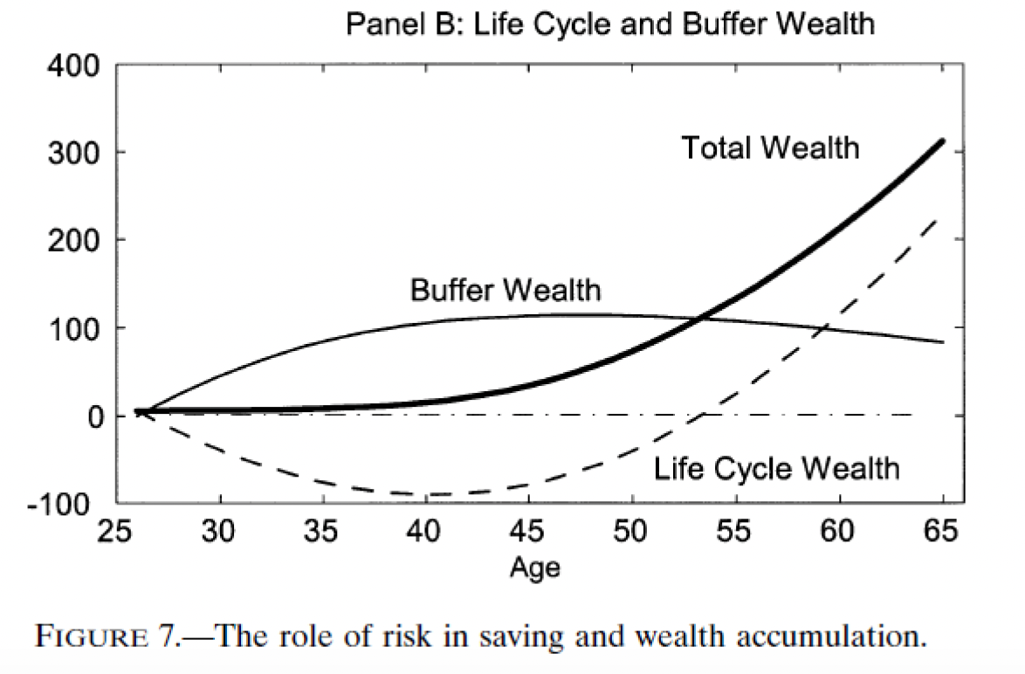
Bellman equation:
$$V_{t}\left(S_{t}\right)=\max_{C_{t}}{U\left(C_{t},S_{t}\right)}+βE_{t}\left[V_{t+1}\left(S_{t+1}\right)\right]$$
Blue variables – state variables
Red variables – choice variables
Simplest version of the buffer-stock model:
$$V_{t}\left(M_{t},P_{t}\right)=\max_{C_{t}}{\frac{C_{t}^{1-ρ}}{1-ρ}}+βE_{t}\left[V_{t+1}\left(M_{t+1},P_{t+1}\right)\right]$$
$$s.t.$$
$$A_{t}=M_{t}-C_{t}$$
$$M_{t+1}=RA_{t}+Y_{t+1}$$
$$Y_{t+1}=P_{t+1}ς_{t+1}$$
$$P_{t+1}=GP_{t}ψ_{t+1}$$
$$A_{t}≥0,∀t$$
Where: $E_{t}\left[V_{t+1}\left(M_{t+1},P_{t+1}\right)\right]=E_{t}\left[V_{t+1}\left(M_{t+1},P_{t+1}\right)\right]$
In all periods we will behave optimally.
WE ALWAYS solve by backwards induction (from the terminal period as we know people are going to die). In the last period everything is consumed.
Normalization I:
Defining $c_{t}≡\frac{C_{t}}{P_{t}}, m_{t}≡\frac{M_{t}}{P_{t}}$ etc. implies:
$$A_{t}=M_{t}-C_{t}$$
$$a_{t}=m_{t}-c_{t}$$
And state transition:
$$M_{t+1}=RA_{t}+Y_{t+1}$$
We have to normalize using the same period ($P_{t+1}):$
$$\frac{M_{t+1}}{P_{t+1}}=\frac{RA_{t}}{P_{t+1}}+\frac{Y_{t+1}}{P_{t+1}}$$
$$m_{t+1}=\frac{Ra_{t}P_{t}}{P_{t+1}}+ς_{t+1}$$
$$m_{t+1}=\frac{R}{Gψ_{t+1}}a_{t}+ς_{t+1}$$
The adjustment factor $\frac{1}{Gψ_{t+1}}$ is due to changes in permanent income. Now I need to know small letter m and choose small letter $c_{t+1}$.
Labor supply and taxes: A Survey – Michael P. Keane
- What is the main research question?
How responsive is labor supply to changes in wages and taxes, and what are the implications for optimal tax design? He investigates how much people change their work hours when taxes or wages change. He also looks at why these elasticities vary so much across different studies.
So are economists underestimating how much taxation distorts labor supply decisions?
- What is the (empirical) motivation?
Understanding labor supply elasticities is crucial for optimal tax policy design. Taxation causes people to work less as they get a smaller slice of the cake, reducing total economic output. Current policy debates assumes small elasticities – meaning low efficiency cost of high taxes. He believes existing methods have systematic problems that lead to underestimation of true elasticities.
- What are the central mechanisms in the model?
- Static model mechanisms: Basic trade-off between leisure and consumption
Substitution effect: Higher after-tax wage means work is more rewarding giving you incentive to work more. Determined by the $γ$ in utility function.
Income effect: Higher wage/income means that you afford more leisure and thus work less. Determined by parameter $η$ in utility function.
Tax policy effect: A higher tax-rate reduces the after-tax wage and affects both substitution and income effect. Net effect depends on whether substitution or income effect dominates.

- Life-cycle model with savings: Adds intertemporal substitution (Frisch elasticity).
Intertemporal substitution is an economic concept where individuals adjust their consumption and savings behavior over time based on changes in real interest rates.
People can shift work between periods by saving and borrowing.
If wages are temporarily high Work more now, save more, consume later.
If wages are temporarily low Work less now, consume more from savings.
Shows that workers not only respond to the wage level but to wage changes over time.

- Life-cycle model with human capital
Working more today accumulates more experience resulting in higher future wages, which creates an additional incentive to working when young. So current work decisions have investment value for future earnings.
Women more sensitive to income changes
Going to work costs money (childcare, gas, clothes). If your wage barely covers these costs, you might not work at all. A small pay raise can make the difference between working and staying home. When women's wages go up, they often:
- Wait longer to have kids (so they can work more first)
- Make different marriage choices
- Get more education
These choices stack up over time, making long-term effects much bigger than short-term effects.
Bottom line: Women's work decisions are more sensitive to wages than men's, especially the choice of whether to work at all.
- What is the simplest model in which we could capture these?
Level 1: Basic static model
Utility:
$$U =\frac{C^{1+η}}{1+η} - β·\frac{h^{1+γ}}{1+γ}$$
Budget:
$$C = w\left(1-τ\right)h + N$$
Captures the substitution and income effect but does not take dynamics, savings and human capital into account.

Level 2: Two-period life-cycle (with savings)
Adds borrowing and saving between periods – captures intertemporal substitution (work more when wages are temporarily high) but does not take human capital and demographics into account.
Level 3: Life-cycle with human capital
Adds the fact that working today increases future wages through experience. Captures investment motive for working.
Level 4: Full dynamic (for women)
Takes fertility, marriage, education into account and how these decisions respond to wages. Captures long-run effects much more than short-run.
Which Model to Use?
- Quick calculations: Level 1 (but likely biased)
- Male labor supply: Level 2-3 minimum
- Female labor supply: Level 4 recommended
Keane's argument: Most studies use oversimplified models → systematic underestimation of how responsive labor supply really is.
Life cycle labor supply with human capital – Keane (2016)
- What is the main research question?
What happens to labor supply elasticities when we allow work experience to affect wages?
The standard model (MaCurdy 1981) treats wages and taxes as exogeneous and consistently finds elasticities near zero. This would suggest that wages and taxes do not affect labor at all, and that high tax rates in theory would be relatively costless.
Keane argues that this conclusion is wrong – if working today raises your future wages then the wage alone understates the true reward for working. The true price of time is the wage plus the return to experience, say $20 (wage) + $10 (value of experience gained) = $30. Ignoring this fact as MaCurdy biases all elasticity estimates downward and the data are actually consistent with much larger elasticities.
- What is the (empirical) motivation?
In the standard model from MaCurdy, if wages go up a lot and hours barely move, you conclude people don’t respond to wages and can therefore conclude an inelastic labor supply. Keane thinks this reasoning is flawed. He argues that you need to recognize that young workers also earn a large (unobserved) experience premium, that the effective price of time rises more slowly than the wage – and the slow hours growth becomes consistent with elastic supply.
- What are the central mechanisms in the model?
All follow from one idea: Work experience builds human capital, so current labor supply affects future wages.
- Wage $≠$ price of time. The true opportunity cost is the wage plus the present value of future wage gains from experience. This extra term is large for the young, zero near retirement.
- Estimation bias. Regressing hours growth on wage growth overstates effective price growth and understates responsiveness – by a factor of roughly 3,3x. Instruments can’t fix this.
- Age-varying elasticities. Young workers have low elasticities (taxes only hit the wage, not the experience return). Older workers have high elasticities (experience term doesn’t matter).
- Permanent > Transitory tax effects. A permanent tax reduces both the wage and the return to experience; a transitory tax only hits the wage. So permanent taxes can have larger substitution effects.
- Snowball effect. A permanent tax reduces hours slows human capital accumulation (productivity, experience etc.) Lowers future wages Further reduces hours. In the Imai–Keane simulations, a 5% permanent tax increase at age 25 reduces wages by just 1% at age 40 but 11.6% by age 65. This is why the long-run compensated elasticity (1.3) far exceeds the short-run average (0.70).

- What is the simplest model in which we could capture these?
Keane builds it by adding an extra linear learning-by-doing wage equation onto the standard MaCurdy model. It consists of three components.
- Preferences: Workers have standard utility over consumption and leisure, with parameter $γ$ being income effects and parameter, $c$ being the willingness to substitute work across time.
- Budget constraint: Workers can save and borrow freely at interest rate, $r$. With the simplification: $β\left(1+r\right)=1$, consumption is constant and equals the annuitized value of lifetime earnings.
- Human capital (key addition): The wage evolves as:
$$w_{t}=\overline{w}(1+α·Σh_{s})$$
Where cumulative hours map into higher wages through parameter, $α$. Each extra hour of work raises the wage by $α\overline{w}$ in every future period.

A two-period version (each period = 20 years) is enough to demonstrate the 3,3x estimation bias and the reversal of permanent vs. transitory tax effects.

